Emotional AI Mirror
Draft Project Report
Template 4.1: Orchestrating AI models to achieve a goal
CM3020 Artificial Intelligence - Project Idea 1, Template 4.1
Word count: 7500 (excluding headings, figure and table captions, tables and references)

1. Introduction
This project is a privacy-focused proof of concept for emotional self-reflection. It combines facial-emotion classification, speech transcription, text-emotion analysis and a local language model in a single guided session. Users view an emotional stimulus while their facial responses are sampled, answer three spoken questions, and receive a personalised, non-diagnostic reflection based on the resulting signals. All processing is designed to remain on the user's device. The prototype is explicitly not a diagnostic or therapeutic system: its outputs are hypotheses for reflection, not reliable measurements of internal psychological states or substitutes for professional care.
The project uses Template 4.1: Orchestrating AI models to achieve a goal (CM3020 Artificial Intelligence, Project Idea 1, section 4.1).

Project goal, aims and objectives
The goal is to demonstrate whether heterogeneous, locally executed AI components can be orchestrated into a usable and privacy-preserving reflection workflow without presenting model outputs as clinically valid psychological measurements.
The project has four aims: implement a complete consent-first local pipeline; compare candidate models using reproducible component-level measurements; evaluate end-to-end robustness, latency and user-facing behaviour; and identify safety, privacy and validity limitations that prevent the prototype from being treated as a diagnostic tool.
The draft uses measurable technical objectives rather than a claim of psychological accuracy: complete three end-to-end runs; retain only locally executable components; report exact categorical results and latency for fixed benchmark inputs; pass the project's own automated tests; and collect early user feedback on how clear the output was, how accurate it felt, and whether people would use the system again.
Most people struggle to understand their own emotions. Professional support is expensive and not always accessible. Mental health disorders constitute five of the top ten causes of disability across Europe, with an estimated total cost exceeding €600 billion annually (Laidi et al., 2023). This tool targets two groups: those who cannot afford professional therapy, and those who experience anxiety or stigma when discussing mental health with strangers.
Similar technology already exists but serves different purposes. Affectiva, a commercial product born out of MIT Media Lab, uses computer vision to classify facial expressions into emotion categories in real time. However it is built for corporate use, its primary application is measuring consumer reactions to advertisements. The insights go to the advertiser, not the person being analysed. It is expensive, closed source, and inaccessible to individuals.
A more recent example is Ghatoray and Li (2025), from Brunel University London, who combined facial emotion recognition, speech-to-text, and sentiment analysis, feeding everything into a language model, a pipeline technically very similar to this project. However their system only processes pre-recorded video, is not interactive, and uses GPT-4o, a paid cloud service. The authors themselves flagged this as a privacy concern.
This project addresses both gaps: it uses a live webcam feed instead of pre-recorded video, and runs the language model entirely locally using Ollama. Rather than producing a static report for a researcher or feeding data to an advertiser, the system opens an interactive conversation with the user, putting the insight back in the hands of the person it came from.

2. Literature Review

2.1 Multimodal emotion-related systems
Existing systems show that emotional signals can be picked up from faces, voices and text, but they vary widely in what they are built for, how users interact with them, and how strong the evidence behind them is. Affectiva represents a commercially mature approach: it combines facial, vocal and other behavioural signals for real-time analysis, primarily for organisational applications such as advertising and customer research (Affectiva, 2016; Miller, 2017). Ghatoray and Li (2025) provide a closer technical comparison to this project by combining facial emotion recognition and text sentiment before using a language model to produce higher level insights. Their work supports the case for combining several signal types, but it runs on pre-recorded research videos and relies on GPT-4o, a cloud service. It therefore shows nothing about whether a live, locally run system can safely draw conclusions about a user's psychological state. These examples show that combining models in this way is technically workable, while making one point clear: successfully merging signals is not the same as measuring emotion accurately.

2.2 From emotion classification to psychological inference
The key scientific question is what an emotion label actually tells us. Barrett et al. (2019) reviewed more than 1,000 studies and challenged the assumption that a given facial expression reliably points to a specific inner emotion. They identify four problems: the same emotion can appear on the face in different ways, the same expression can occur in different emotional states, and the link between the two shifts across people, situations and cultures. This limits any system, including Affectiva and this project, that treats a facial label as what a person actually feels. It matters especially here because DeepFace labels one frame at a time, and those labels are then handed to a language model that turns them into smooth, readable prose. This project treats facial and text-emotion outputs as rough signals to reflect on, not as measurements or diagnoses of what someone feels inside.

2.3 Multimodality, context and model limitations
The literature also suggests that using only one signal is limiting. Affectiva's multimodal design and Ghatoray and Li's mix of facial and text data both show the practical value of watching several channels at once. This project therefore combines facial movement, speech, text emotion and language generation to give the user something richer to reflect on than any single classifier could offer. But combining signals should be seen as a way of cross-checking, not as proof. If the underlying models are biased, missing context or unsure, merging their outputs makes the story sound more convincing without making it any more accurate. This is why the project tests each component on its own, then tests the whole pipeline and records where it fails. The fact that DeepFace and the chosen text-emotion model share the same seven emotion labels is likewise a practical convenience that makes comparison possible.

2.4 Application context: support, agency and privacy
Application context changes the requirements for an emotion-related system. Abby AI provides a useful contrast: it prepares a structured patient summary for a clinician, while the professional remains responsible for interpretation and decision-making (Abby Health, 2026). The present project removes that professional intermediary and presents the generated reflection directly to the user, so it cannot inherit the same safeguard of clinician oversight. This makes scope, consent and communication of uncertainty central design requirements rather than optional additions. Privacy is similarly consequential. Commercial systems such as Affectiva demonstrate the feasibility of large-scale emotion analysis but are oriented towards organisational users, whereas this project deliberately keeps processing local so that sensitive webcam, audio and generated-profile data are not transmitted to a cloud service. These contrasting applications therefore lead to a narrower project position: a local, interactive proof of concept for self-reflection, rather than an autonomous mental-health assessment tool.

2.5 Synthesis and implications for this project
Taken together, the literature supports three conclusions that shape this project. First, multimodal AI pipelines work in practice and can combine signals that complement each other, as both commercial systems and recent research show. Second, the scientific evidence does not support treating facial expressions as direct, reliable measures of inner emotion, which sets a hard limit on what this prototype can claim (Barrett et al., 2019). Third, a system used directly by individuals around their own wellbeing needs stronger safeguards than one built for advertising or for supporting clinicians. These conclusions shape the project's design, namely local processing of all signals, explicit consent, non-diagnostic wording and clear signposting to professional help, and they also set the limit on what counts as success. Table 1 summarises this comparison. The right question to ask is therefore not whether the system can read a person's psychological state, but whether it can combine several imperfect signals into a clear, private reflection process that is honest about its own uncertainty and limits.
Approach | What it demonstrates | Key limitation | Project implication
Abby AI | AI-generated structured profiles | Clinician remains responsible | Direct-to-user output needs stronger scope and safety framing
Affectiva | Real-time multimodal analysis | Commercial context and uncertain psychological inference | Supports feasibility, not validity; motivates local processing
Ghatoray & Li (2025) | Facial + text + LLM pipeline | Pre-recorded video and cloud GPT-4o | Supports multimodal architecture while motivating local interactive design
Emotional AI Mirror | Local multimodal reflection workflow | No validated ground truth; inherited model bias | Proof of concept for self-reflection, not diagnosis
Table 1. Comparison of the reviewed approaches against the position taken by this project.

2.6 Techniques and methods
This project combines several pre-trained models to achieve a common goal across four domains: vision, audio, text, and language generation. The library and model choices below were explored starting from more demanding options and downgraded to lighter frameworks where hardware constraints required it.

OpenCV, Computer Vision Library
OpenCV is an open-source library for detecting faces and tracking movement in videos. It runs locally on the user's machine, so the data stays private. The library is cross-platform and licensed as free and open-source software (OpenCV, 2026), making it well suited to this project.

Whisper / faster-whisper, Speech-to-Text Model
For speech recognition the project uses Whisper, an open-source speech recognition model created by OpenAI (Radford et al., 2022), trained on 680,000 hours of multilingual audio and supporting 99 languages. It runs locally without needing an internet connection. In practice the project uses faster-whisper (SYSTRAN, n.d.), a reimplementation that runs roughly four times faster on CPU at equivalent accuracy, which matters given the target hardware has no dedicated GPU.
Whisper transcribes what the user says during the session; the transcribed text is then analysed for sentiment and emotional tone (Radford et al., 2022).
faster-whisper was benchmarked directly against the original openai-whisper on the same audio file (both at the tiny model size, see Evaluation, Stage 2 results). faster-whisper was confirmed faster on transcription and, on this test file, more accurate: openai-whisper mis-transcribed one word ('microphone' as 'Micah Cup') where faster-whisper transcribed the file correctly. Vosk was also considered as a lighter-weight fallback option (see Design chapter) but was not directly benchmarked, since the openai-whisper comparison already demonstrates the accuracy/performance case for faster-whisper against the model it is built on.

Sentiment / Text Emotion Detection
To detect emotion in text, the transcribed speech from Whisper is fed to a pre-trained model to identify emotional tone and sentiment. These models can be downloaded and run locally, using deep learning to classify text as positive, negative, or neutral, or to detect more nuanced emotions like frustration, joy, or sadness (Hugging Face, 2024).
Three candidates were benchmarked on a fixed set of test transcripts: VADER, a rule-based analyser (Hutto & Gilbert, 2014); tabularisai/multilingual-sentiment-analysis; and j-hartmann/emotion-english-distilroberta-base. j-hartmann (Hartmann, 2022) was selected, both for its higher accuracy on the test set and because it shares the same seven-emotion label space as the DeepFace facial-emotion model, allowing facial and verbal emotion to be compared directly. Full results are given in the Evaluation chapter.

Ollama, Local Language Model Framework
For the interactive component the project uses Ollama, a framework that allows large language models to run locally without an internet connection or cloud services (Ollama, 2024). Ollama generates the final non-diagnostic reflection and personalised recommendations from the combined facial emotion, transcribed speech, and sentiment data. Because Ollama runs entirely on the user's machine, all emotional data stays private and is never sent to external servers (Ollama, 2024).
llama3.2 (approximately 2GB) was used for initial integration, chosen as the smallest widely-used Ollama model and confirmed to run on CPU-only consumer hardware without a dedicated GPU.
llama3.2 and qwen2.5:3b were benchmarked on an identical sample prompt (see Evaluation, Table 8). qwen2.5:3b was notably faster on both time-to-first-token and total generation time, but its reply did not include a recommendation to seek professional help despite the sample containing a fear signal comparable to earlier tests where llama3.2 reliably included one. Given the project's severity-assessment design requirement, llama3.2 was retained as the primary model, with qwen2.5:3b noted as a faster alternative worth further, more systematic safety testing.

2.7 Study cases and research evidence
To assess the risks of AI-generated mental-health conclusions this project draws on a study by Alyssa Ezell, conducted at Widener University, testing whether six AI chatbots, three general-use (ChatGPT, Gemini, Claude) and three therapist-specific (Pi, Panda, Abby), could accurately diagnose mental health conditions and create treatment plans (Ezell, 2026).
General-use chatbots provided diagnoses in 100% of cases, but only 36.7% were completely correct; in 40% of cases, chatbots gave both correct and incorrect diagnoses simultaneously (Ezell, 2026). Therapist-specific chatbots were more cautious, providing diagnoses only 53.3% of the time. For treatment planning, general-use chatbots recommended plans in 93.3% of cases, most commonly Cognitive Behavioral Therapy, psychiatric medication, and social support, but these recommendations were very generic (Ezell, 2026).
Ezell's research demonstrates that AI can provide mental health information, but current systems struggle with accuracy, personalisation, and transparency. This project does not claim to resolve the accuracy problem Ezell identifies. It responds instead by narrowing the claim: outputs are framed as non-diagnostic reflection rather than assessment, and processing is kept local so that the transparency and privacy concerns raised in that work are not compounded.

2.8 Scientific validity of facial-emotion inference
As established in Section 2.2, DeepFace's frame-by-frame labels should not be read as a direct measure of internal emotional state, and passing them through a language model only adds fluency, not validity. This has a direct consequence for how the evaluation in this report should be read: agreement between two facial classifiers is not evidence that either is psychologically correct, and a user's agreement with a generated reflection is not a clinical ground truth. The appropriate claim for this submission is therefore proof of concept, the system demonstrates a technically functioning multimodal pipeline and exposes where robustness and validity remain unresolved, rather than demonstrating accurate emotional measurement.

3. Design

Domain
Laidi et al. (2023) report that mental disorders constitute five of the top ten causes of disability across Europe, with an estimated total cost exceeding 4% of GDP, more than €600 billion annually. They also note that these conditions often begin early in life, with significant impacts on work productivity and quality of life.
The primary users of this product are individuals aged 18-45 seeking mental health support in Europe. The scale of the problem is considerable: in France alone, Laidi et al. (2023) estimate the annual cost of mental health at €163 billion in 2018, broken down into direct healthcare costs (14%), productivity loss (27%), and loss of quality of life (51%). These costs reflect both the prevalence of mental health conditions and barriers to access, with anxiety and depressive disorders being the most common conditions, affecting millions of people across the continent.
Affordability is not the only issue: discomfort with human interaction is also a critical barrier. While people generally prefer human doctors to AI systems, there is evidence that a fully automated chatbot can lower the perceived barrier to disclosing personal difficulties, because users feel less exposed to judgement than with another person (Lee et al., 2022); some individuals may therefore engage with AI-based tools when human interaction feels inaccessible or uncomfortable (Riedl et al., 2024).
This tool targets two user groups: those who cannot afford professional therapy, and those who experience anxiety or stigma when discussing mental health with strangers. The system is designed to identify signals that warrant cautious signposting; if a user's profile indicates serious mental health concerns, the system actively encourages them to seek professional help. It is not a replacement for therapy, but a meaningful first step toward self-awareness and care-seeking.

Design justification
The design choices in this project are based on the specific needs identified in the domain and user analysis: privacy, affordability, accessibility, and responsible care-seeking.

Fully local processing
To address privacy concerns that are especially important in mental health contexts, the entire system runs locally, with no internet connection or cloud services. Riedl et al. (2024) found that perceived privacy invasion was higher in AI-based interactions, and higher still in psychiatry than in other medical fields, where patients fear data breaches when discussing personal conditions. By keeping all emotional data on the user's machine, the system removes this barrier entirely. This is also what separates the project from commercial products like Affectiva, which send insights to third parties rather than the user.

Multiple models across different domains
The system combines facial emotion recognition, speech transcription, sentiment analysis, and a local language model. This is because people often find it hard to put their feelings into words, and what they say does not always match what their face shows. Using more than one source of information gives a fuller picture than any single model could. Recent work in the field follows the same logic: Ghatoray and Li (2025), for example, combined facial emotion recognition with text sentiment because no single model captured the full emotional picture on its own.

Interactive conversation
After the session signals have been processed, the system opens a dialogue through the local language model instead of producing a static diagnostic label. This matters because the target users are often approaching mental health for the first time and need guidance, not just a label. An interactive format lets them ask questions, explore recommendations, and feel heard. Lee et al. (2022) found that AI chatbots can foster rapport and self-disclosure, which is valuable for users who feel anxious or embarrassed talking to a stranger.

Safety signposting and scope boundary
The system is not designed to replace therapy. When a user's profile suggests serious concerns, it encourages them to seek professional help. The evidence is clear that people prefer and benefit from human care (Riedl et al., 2024), and an AI tool that masks the need for real treatment would be harmful. This project recognises the importance of human connection in effective mental healthcare, and treats itself as a first step rather than a substitute.

Inclusive design
The system needs no subscription, no referral from a clinician and no paid appointment. It runs entirely on a personal laptop, and nothing is sent off the device. For someone who cannot afford therapy, or who feels uncomfortable discussing mental health with another person, being able to reflect privately at no ongoing cost is itself an argument for inclusion, and it serves the two user groups identified in the Domain section above.
Against this, every pre-trained model in the pipeline carries demographic bias that this project inherits rather than fixes. Facial-analysis models are well documented to work unevenly across skin tone and gender: the Gender Shades audit found commercial gender-classification error rates below 1% for lighter-skinned men, against over 30% for darker-skinned women (Buolamwini & Gebru, 2018). This project's own DeepFace errors (see Evaluation, Stage 1 results) came from a single tester, so nothing can be assumed about how the model behaves for users with different skin tones or genders, either in how often it fails or in which way. Whisper and faster-whisper show the same pattern for speech: word error rates rise measurably for non-native and non-American accents compared with American and Canadian speakers (Graham & Roll, 2024). A user's accent could therefore quietly degrade the transcript that feeds every later stage, without the user ever being told. Finally, the terminal and OpenCV interface (see Session flow and user interaction) was chosen for development speed rather than accessibility. It has no screen-reader support, and the picture-in-picture display makes no accommodation for colour-blindness or low vision, so a user who cannot read the terminal clearly cannot use the tool at all. None of these three limitations was addressed in this build.

Ethical safeguards, privacy management and crisis boundary
Because the prototype works in an area close to mental health, the design treats safety as a fixed boundary in the code rather than something read off the model's confidence scores. The safeguards built in are: consent before anything runs, a clear statement that the tool does not diagnose, refusal that fails safely, processing kept on the device, consent recorded for each session, and signposting to professional support at the end of every session. These measures follow WHO guidance that AI used in health settings should protect autonomy, privacy, safety, transparency and inclusiveness (World Health Organization, 2021).
The prototype is not suitable for handling crises, nor for unsupervised use by vulnerable people going through severe mental-health difficulties. A local language model can miss signs of distress, read them wrongly, or overreact to them, and the current evaluation gives no evidence that it can reliably spot suicidal intent or other emergencies. The closing resources are therefore a signpost, not a way of detecting a crisis. A real product would need a separately tested safety pathway, explicit crisis messaging, a route to a human, or emergency-service guidance suited to the user's location, along with testing on realistic safety cases, before it could claim to support anyone in crisis.
Privacy also means more than keeping data off the network. Nothing is sent to the cloud, but the system does write sensitive session logs to the local device, so privacy still depends on who can access that device and on how long the logs are kept. The current prototype gives the user no retention period and no way to delete their data. A future version should show what is stored, where it is stored and for how long, and give the user a way to delete it immediately.

Structure of the project
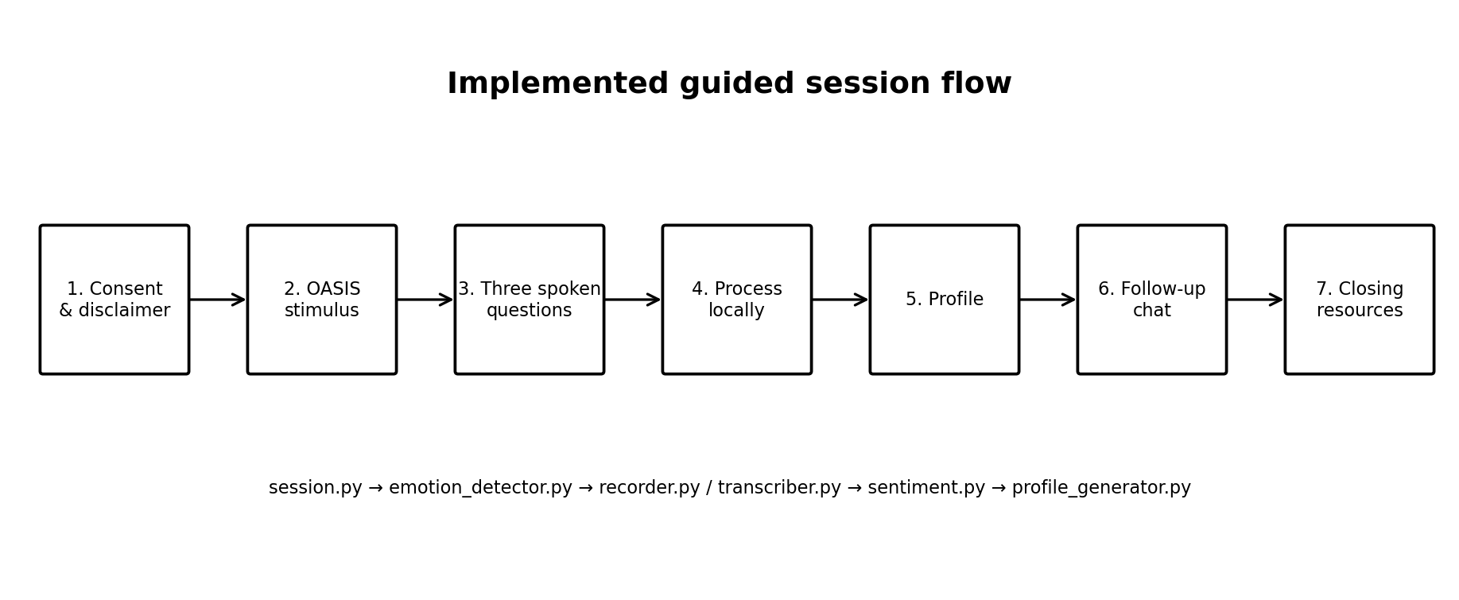
Figure 1. Implemented seven-step user session flow, from consent through stimulus, spoken responses, local processing, profile generation, follow-up chat and closing resources.
The user sits in front of their laptop and watches a short sequence of emotionally provocative images. While this happens, the webcam captures live video with the user's consent and feeds it to a facial emotion recognition model (DeepFace), which samples frames in real time and classifies each into one of seven emotion categories. The complete interaction sequence is summarised in Figure 1.
The system then asks the user a few questions, which they answer aloud. Their voice is transcribed by Whisper (faster-whisper), running locally. The resulting text is passed to a sentiment analysis model, which identifies the emotional tone behind what the user said.
All the data collected so far - facial reactions, transcribed answers, sentiment scores - is then fed to a local language model running through Ollama. The model synthesises everything it has observed and opens an interactive conversation with the user, letting them ask questions and explore their results.
Finally the system delivers a personalised, non-diagnostic reflection consisting of a summary of detected emotional patterns, reported concerns, and personalised wellbeing recommendations, alongside practical suggestions: books to read, meditation practices, focus areas to work on, and lifestyle suggestions. If the profile indicates serious concerns, the system actively encourages the user to seek professional help from a qualified therapist.

4. Implementation

Orchestration overview
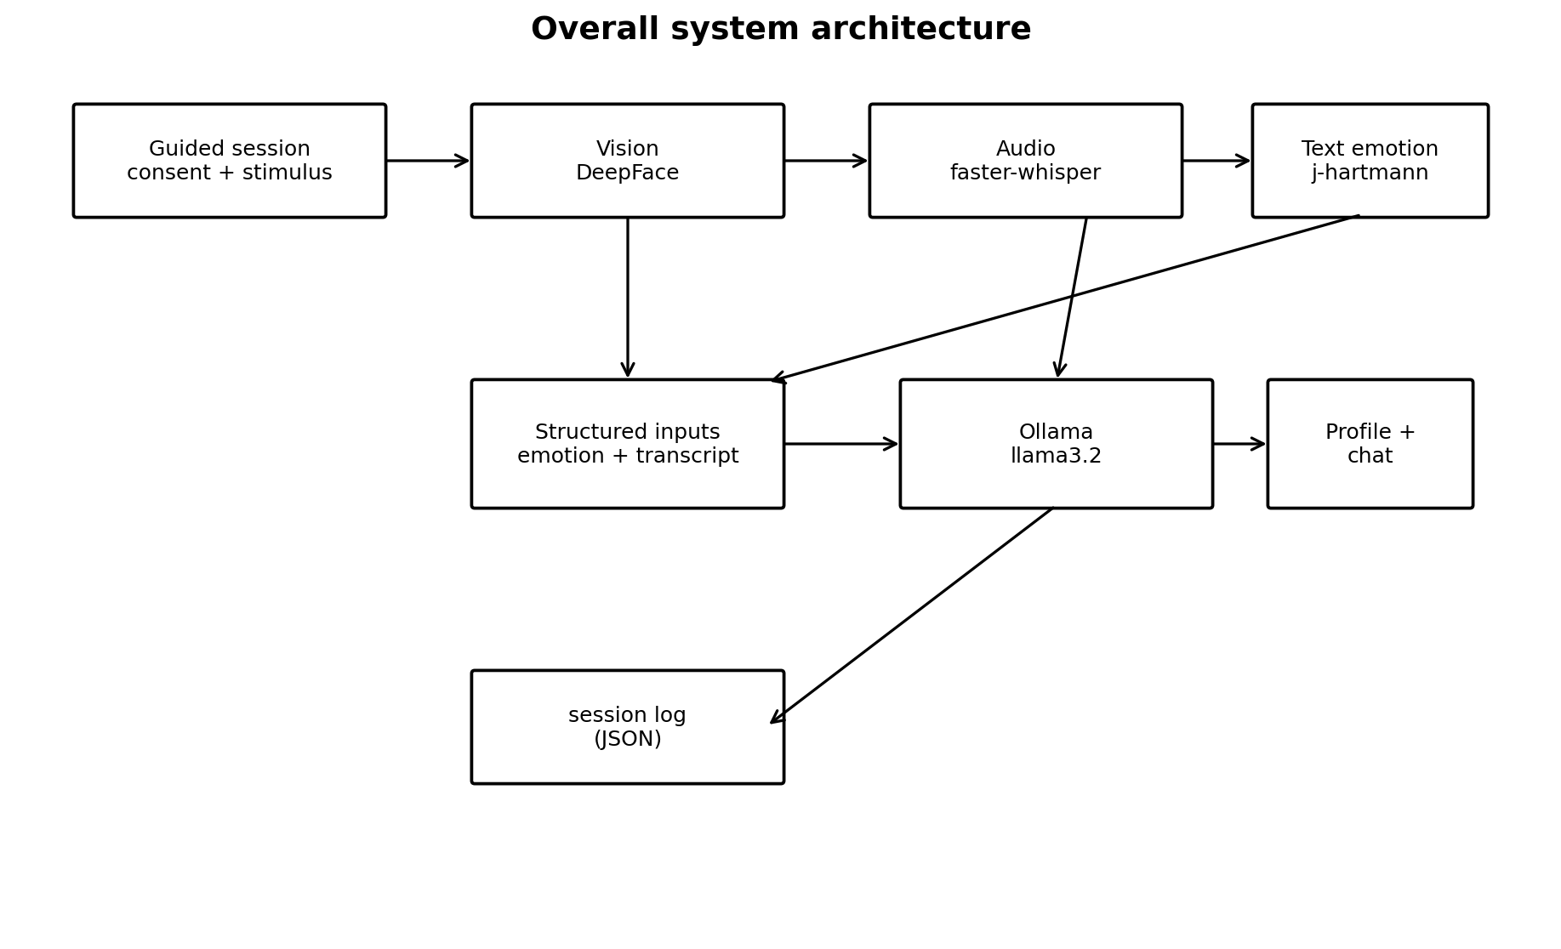
Figure 2. Overall architecture of the Emotional AI Mirror, showing the four model stages, orchestration and local session logging.
A pipeline.py module acts as the orchestrator. Each model lives in its own module with a clean interface (a class or a run function returning a small structured result), and pipeline.py is solely responsible for sequencing the stages and passing data between them. This keeps each model self-contained and independently testable, and allows stages to be added without changing the modules already written. Figure 2 summarises the resulting architecture and data flow.
Each completed run is saved as a timestamped JSON session log containing consent status, demo status, stage outputs, the three question-and-answer pairs, the generated profile and chat history. This makes each session auditable and distinguishes real participant sessions from demonstrations.

Stage 1: Facial emotion recognition (DeepFace)
DeepFace (Serengil & Ozpinar, 2020) performs facial-emotion classification from webcam frames. Each sampled frame is analysed independently and mapped to one of seven emotion labels; the lack of temporal context is relevant to the direction-inconsistent misclassifications reported in Evaluation.
The vision stage exposes run_session() and a separate summarise_timeline() function, allowing the deterministic summarisation logic to be tested without webcam hardware. Figures 4 and 5 show the earlier single-window build used to confirm that DeepFace ran at an acceptable frame rate on the target hardware before the stimulus display was added.
OASIS (Kurdi, Lozano & Banaji, 2017) replaced the placeholder scenes shown in Figure 3. Its normative valence and arousal ratings support deliberate selection of stimuli across threatening, joyful, sad and relaxing conditions. IAPS was considered but was not obtainable through an official route at the time of development, so OASIS was selected as the practical and openly available alternative.
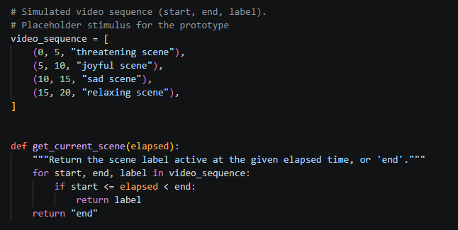
Figure 3. The placeholder stimulus schedule used in the feature prototype: four hard-coded scene labels on fixed timestamps, with get_current_scene() returning whichever label is active. This was replaced by the OASIS-driven schedule described above.
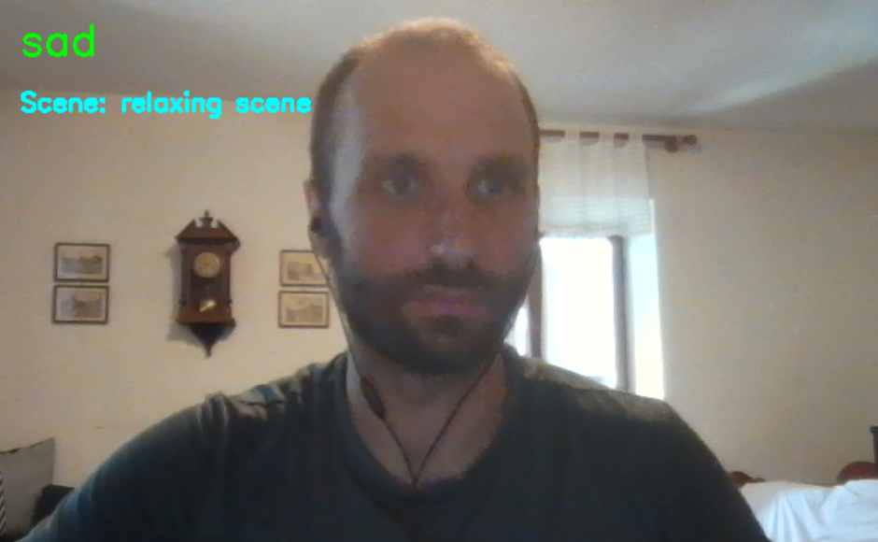
Figure 4. An early single-window build, before the picture-in-picture layout, with DEBUG_OVERLAY enabled. The frame is labelled sad during the relaxing scene - an instance of the direction-inconsistent misclassification of the same kind as those reported in Evaluation, Stage 1 results.
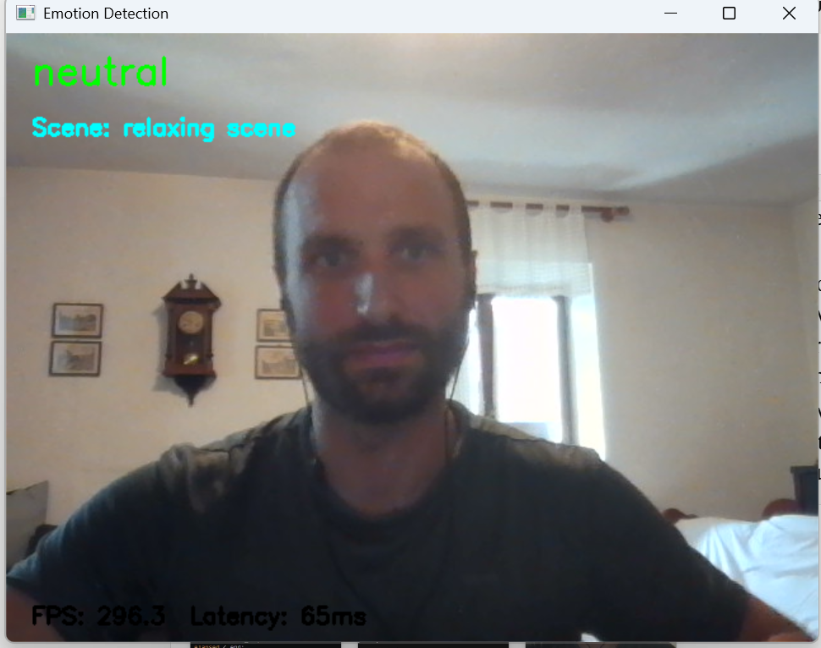
Figure 5. The same build with the FPS and per-analysis latency counters used to confirm that frame capture remains fluid while DeepFace is sampled every tenth frame on CPU-only hardware.

OASIS integration and picture-in-picture display
The final display uses a picture-in-picture layout: the stimulus occupies the main window and the webcam feed appears as a small inset. Figure 6 shows the resulting window. A DEBUG_OVERLAY flag exposes scene/emotion labels for development but remains disabled during real sessions so participants are not prompted by the system's own interpretation.

Figure 6. The running session with a real OASIS stimulus filling the window and the live webcam feed inset bottom-right, shown here with DEBUG_OVERLAY enabled so the active scene label, the live detected emotion, and the FPS/latency counters are visible. All three overlays are hidden by default during a real session.

Stage 2: Speech-to-text (Whisper / faster-whisper)
The project uses faster-whisper rather than the original openai-whisper, since it runs roughly four times faster on CPU at equivalent accuracy and supports int8 quantisation to reduce memory use - both matter given the project runs locally with no GPU. The component is built as a Transcriber class: the model is loaded once in __init__ and reused for every subsequent call, avoiding the cost of reloading it each time.

Stage 3: Sentiment / text-emotion analysis
The text stage is implemented in sentiment.py, following the same structural pattern as the Transcriber class: a SentimentAnalyzer class loads the chosen model once at construction and exposes a single analyze(text) method that returns a small structured result (an EmotionResult namedtuple of label and confidence score), so the rest of the pipeline always receives a predictable shape regardless of which model sits underneath.
j-hartmann/emotion-english-distilroberta-base was selected after benchmarking it against VADER and tabularisai/multilingual-sentiment-analysis on a fixed set of test transcripts (see Evaluation, Stage 3 results, for the full comparison). Its key advantage is sharing DeepFace's seven-emotion label space, so facial and verbal emotion can later be compared directly by the language model rather than reconciled across two different vocabularies.

Stage 4: Local language model (Ollama)
The language stage is implemented in profile_generator.py as a ProfileGenerator class that wraps a local Ollama model. A fixed system prompt establishes the scope boundary in the code rather than only in the report: it states that the assistant is not a therapist, forbids diagnosing any medical or psychiatric condition, restricts the output to reflecting observed patterns and general wellbeing practices, and requires a clear recommendation to speak to a mental health professional where the observed patterns suggest significant or persistent distress.
A private _build_prompt() method assembles the three upstream stages into one message: the dominant facial emotion and reading count per scene, the combined question-and-answer transcript, and the text-emotion label with its confidence score. Presenting all three signals in a single structured prompt is what allows the model to comment on a mismatch between expression and speech, which is the reflective content no single stage can produce on its own.
generate_profile() returns a Profile namedtuple of the reply text, the raw text and a seek_help flag. The flag is derived from a keyword check over the reply (for example "professional", "therapist", "counsellor") and is deliberately a secondary signal used by the session layer to decide how strongly to surface support resources; the primary mechanism is the instruction in the system prompt itself. The keyword approach is crude by design and its false-positive behaviour is examined in Evaluation, User testing.
chat() continues the same conversation, appending each user message and reply to a history list held on the instance, so the follow-up conversation retains the profile the model has just written as context rather than starting from an empty state on every turn. The ollama package is imported inside __init__ rather than at module level, matching the lazy-import pattern used for DeepFace, faster-whisper and transformers, so every module remains importable - and unit-testable - on a machine where the heavy dependencies are not installed.

Integration test
run_pipeline() in pipeline.py sequences the four stages and is the only place where data crosses between them. It records the wall-clock duration of each stage into a dictionary as it runs, then writes two artefacts on completion: a timestamped session log holding consent status, demo status, the three question-and-answer pairs, every stage output and the full chat transcript, and a separate timing log holding per-stage seconds with totals reported both including and excluding the user-paced chat.
Consent gates the whole sequence: if get_consent() returns False, run_pipeline() returns before any stage executes, so no webcam frame, recording, transcript or log is produced for a declined session. A --demo flag substitutes the bundled sample audio for live microphone capture and auto-confirms consent, which is what allows the system to be demonstrated on a machine with no working microphone; the flag is recorded in the session log so demonstration runs are never mistaken for participant sessions.

Session flow and user interaction
The four model stages are wrapped in a guided session implemented in session.py, so that what a user encounters is a structured, consent-first experience rather than the developer pipeline the stages alone provide. The flow runs in seven steps: consent and disclaimer, the stimulus sequence with live facial analysis, three spoken questions, processing, the generated profile, the follow-up conversation, and a closing message pointing to professional support.
Consent is handled by get_consent(), which prints a disclaimer stating what will be captured (webcam and microphone), what the system will not do (diagnose, or transmit anything off the machine), that the session is written to a local log file, and how to stop at any point. The check fails closed: only an explicit "yes" proceeds, while a blank line, a refusal, an end-of-file or a keyboard interrupt are all treated as consent withheld. Figure 7 shows the screen presented to the user. Where consent is not given, run_pipeline() returns before any stage executes, so nothing is captured, recorded or logged for a declined session.
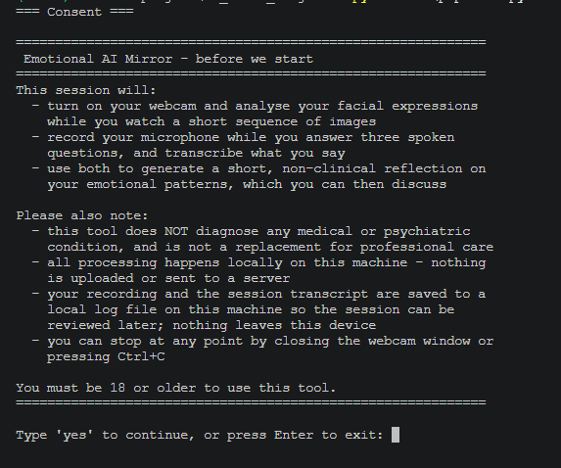
Figure 7. The consent and disclaimer screen shown before any capture begins, stating what is recorded, that the tool does not diagnose, that processing and storage are local, and that the session can be stopped at any point.
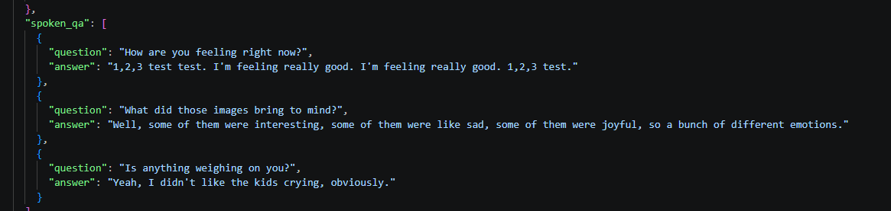
Figure 8. The spoken_qa field of a session log, showing each of the three questions stored alongside the answer it prompted rather than as one undifferentiated transcript.
The session closes with print_closing(), which always displays signposting to professional support and adds a more direct prompt when the seek_help flag is set. Showing the resources on every session rather than only flagged ones is deliberate: it implements the Design chapter's argument that this tool is a first step toward care-seeking, which would be undermined if the signpost appeared only on the sessions a small local model happened to classify as concerning.
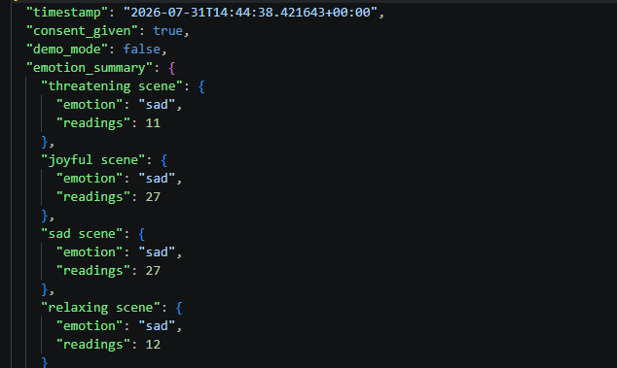
Figure 9. The head of a session log, showing the consent_given and demo_mode flags recorded per session alongside the per-scene emotion summary - evidence that consent is captured per run rather than assumed.

5. Evaluation

Testing methodology
Evaluation uses three complementary levels: isolated model benchmarking, end-to-end integration testing, and user testing. The first stage benchmarks each model in isolation. Model comparisons assess candidate suitability for the target CPU-only hardware and record categorical exactness where ground-truth labels exist; integration tests assess data flow, failure handling and total processing time; user testing examines perceived accuracy, clarity and willingness to use the system again. At system level, the key metrics are completion rate, safety-response consistency, latency and user-rated outcomes. Because the prototype uses pre-trained models and the pilot contains only five convenience-sampled participants, statistical analysis is intentionally descriptive rather than inferential.
The second stage tests how the models connect: whether output from one stage reaches the next in a usable form (e.g. Whisper's transcription passing cleanly to the sentiment model), watching for mismatched data formats, empty or dropped inputs, and total pipeline processing time.
The third stage tests the experience with real users, rating perceived accuracy, clarity and willingness to use the system again on a 1-5 Likert scale. A five-participant pilot of this instrument was completed for this draft and is reported below; the full six-to-ten participant study, which adds a pre-session self-report for comparison against the generated reflection, is scheduled after submission.

Stage 1 results: Facial emotion recognition
One full OASIS sequence was recorded and every per-frame reading logged against the scene active at that moment. Figure 10 plots the result. Readings were dominated by neutral, but two direction-inconsistent errors are visible: a sustained block of happy through the first half of the sad scene, and two isolated fear readings during the relaxing scene. Because each frame is classified independently, a single ambiguous expression can flip the label without any change in what the participant reports feeling.
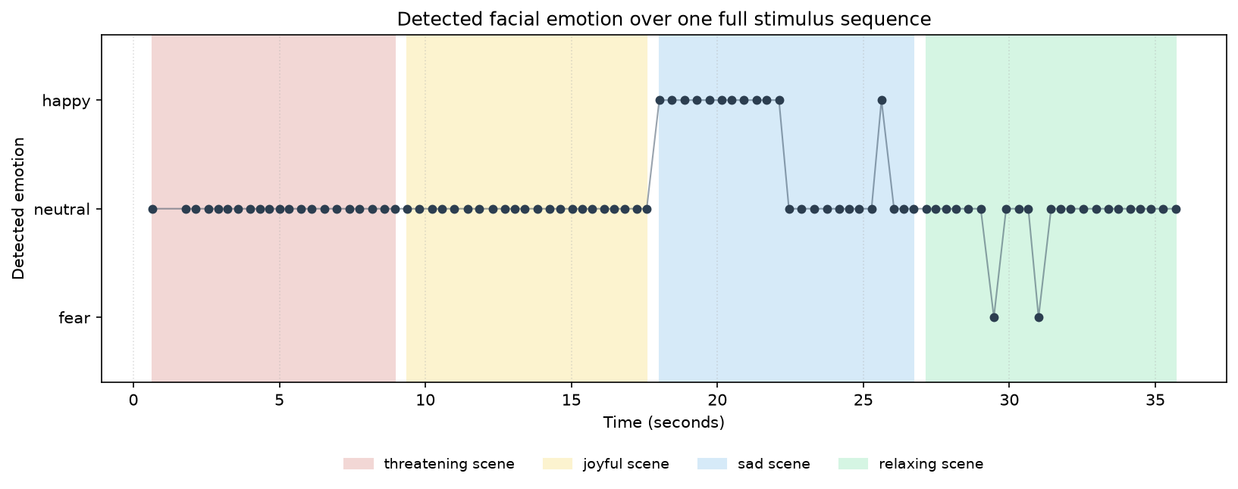
Figure 10. Detected emotion for every reading across one full OASIS sequence, with the four scenes shaded behind. The run is dominated by neutral readings, with a sustained block of happy misclassification through the first half of the sad scene - the direction-inconsistent error described above - and two isolated fear readings during the relaxing scene.

DeepFace vs. FER comparison
DeepFace was benchmarked against FER (a separate Keras CNN emotion model with, by default, a Haar Cascade face detector rather than DeepFace's) using emotion_benchmark.py, sampling one frame per second through both models simultaneously from a live webcam feed. Two runs were carried out.
The first run was not tightly controlled for camera framing (the participant was not consistently facing the camera throughout). Table 2 shows the result: FER failed to detect a face on 7 of 12 sampled frames, against zero missed detections for DeepFace, while both models agreed on every frame where FER did detect a face. This is not treated as a reliable finding about the two models' relative robustness, since it may reflect FER's detector being more sensitive to off-centre framing rather than a genuine reliability gap; it is reported for completeness rather than acted on.
Elapsed (s) | DeepFace label (latency) | FER label (latency) | Agreement
1.0 | happy (425.3ms) | no face detected (14.1ms) | -
4.0 | happy (70.5ms) | no face detected (13.3ms) | -
5.0 | happy (69.7ms) | no face detected (13.2ms) | -
6.1 | happy (65.1ms) | no face detected (13.2ms) | -
7.1 | happy (63.6ms) | no face detected (13.2ms) | -
8.1 | happy (72.3ms) | no face detected (11.1ms) | -
9.1 | neutral (68.7ms) | neutral (17.1ms) | yes
10.1 | neutral (73.9ms) | neutral (13.7ms) | yes
11.2 | neutral (78.1ms) | neutral (15.5ms) | yes
12.2 | neutral (75.0ms) | neutral (12.5ms) | yes
13.2 | happy (63.4ms) | happy (15.3ms) | yes
14.2 | happy (71.8ms) | no face detected (12.9ms) | -
Table 2. DeepFace vs. FER, run 1 (inconsistent camera framing). Average latency: DeepFace 99.8ms, FER 13.8ms. FER detected no face on 7/12 frames.
Elapsed (s) | DeepFace label (latency) | FER label (latency) | Agreement
1.0 | neutral (346.5ms) | neutral (16.5ms) | yes
3.6 | neutral (73.3ms) | neutral (16.4ms) | yes
4.6 | neutral (74.8ms) | neutral (14.9ms) | yes
5.7 | neutral (70.3ms) | neutral (16.0ms) | yes
6.7 | neutral (71.5ms) | neutral (13.8ms) | yes
7.7 | neutral (67.3ms) | neutral (15.1ms) | yes
8.7 | neutral (66.3ms) | neutral (15.6ms) | yes
9.7 | neutral (67.8ms) | neutral (14.0ms) | yes
10.7 | neutral (69.2ms) | neutral (15.4ms) | yes
11.7 | neutral (70.6ms) | neutral (15.0ms) | yes
12.8 | neutral (71.2ms) | neutral (13.7ms) | yes
13.8 | neutral (66.0ms) | neutral (15.4ms) | yes
14.8 | neutral (72.8ms) | neutral (14.5ms) | yes
Table 3. DeepFace vs. FER, run 2 (controlled framing, resting face throughout). Average latency: DeepFace 91.4ms, FER 15.1ms. 13/13 frames agreed.
Run 2 (Table 3) repeated the comparison with the participant facing the camera throughout and holding a resting expression. Both models returned neutral on all 13 sampled frames, agreeing on every one, and FER missed no faces. DeepFace averaged 91.4ms per frame against FER's 15.1ms, so FER is roughly six times faster; DeepFace was nonetheless retained because it detected a face in every frame across both runs and already shares its seven-label vocabulary with the selected text-emotion model. The run also matters as a negative result: under controlled framing the neutral-to-fear/disgust drift seen in earlier informal testing did not reproduce in either model, which suggests that framing and lighting, rather than a property specific to DeepFace, account for a substantial part of the observed instability.

Stage 2 results: Speech-to-text
Both Whisper implementations were run on the same audio file at the tiny model size (Table 4). faster-whisper transcribed the test sentence correctly and completed transcription in roughly half the time of openai-whisper, at a fraction of the peak Python memory; openai-whisper loaded marginally faster but mis-transcribed one word and additionally required a system-level ffmpeg installation. Figure 11 shows the raw benchmark output. faster-whisper was therefore selected, which also verifies rather than merely repeats the performance claim cited in the Literature Review.
Model | Model load time | Transcription time | Peak memory | Notes
faster-whisper (tiny) | 0.74s | 0.54s | 13.4 MB | Transcribed the test sentence correctly in full
openai-whisper (tiny) | 0.44s | 1.05s | 72.1 MB | Mis-transcribed one word ("microphone" -> "Micah Cup"); required a separate system-level ffmpeg install to run
Table 4. faster-whisper vs openai-whisper on an identical audio file, tiny model size, on an Intel Core i7-1185G7, 16GB RAM, no dedicated GPU. Peak memory measured with tracemalloc, isolated per model; this captures Python-level allocations only and likely understates true peak memory, since it does not see inside PyTorch's C/C++ tensor backend.
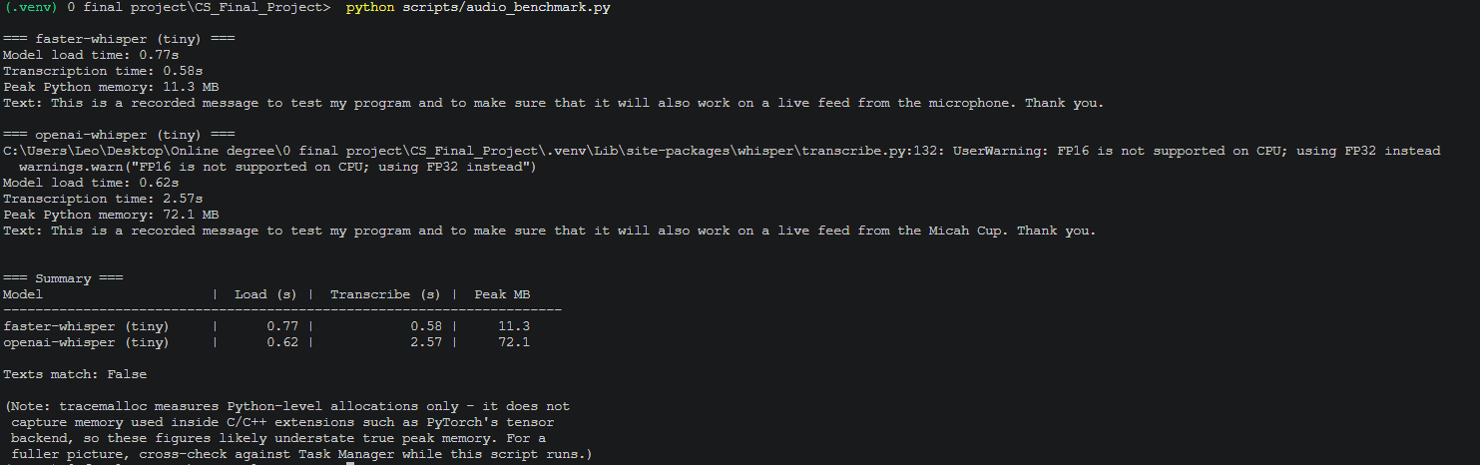
Figure 11. audio_benchmark.py output. The final line of each transcript shows the accuracy difference reported above: faster-whisper returns "microphone" where openai-whisper returns "Micah Cup".

Stage 3 results: Sentiment / text-emotion analysis
Three candidate models were benchmarked on the same 10 test transcripts (see test_transcripts.py): VADER, a rule-based sentiment analyser (Hutto & Gilbert, 2014); j-hartmann/emotion-english-distilroberta-base, a transformer trained on the same seven-emotion label space as DeepFace; and tabularisai/multilingual-sentiment-analysis, a 5-class sentiment model.
j-hartmann was selected. Against the expected labels shown in Table 5, it produced 7/10 exact categorical matches (70%). This should not be interpreted as a validated emotion-recognition accuracy: the test set contains only ten hand-labelled transcripts, one expected class is mixed emotion while the model is single-label, and several classes have only one example. The result therefore helps choose between models, but says nothing about how the model would perform in general. It also uses the same seven labels as DeepFace, which makes it possible to compare the two later on, even though what those labels really mean psychologically is still uncertain.
For a more informative view than overall accuracy alone, the benchmark can be described using exact-match accuracy (7/10 = 70%) and macro recall over the eight expected categories represented in the test set (62.5%). The low macro recall reflects that sadness, anger and mixed emotion were not recovered in this small sample. Reporting both figures matters for categorical exactness: a single overall accuracy figure conceals which categories fail and whether the label space itself is appropriate.
Text | Expected | VADER | j-hartmann | tabularisai
Honestly I feel really good today... | happy | positive | joy | Positive
I don't know, I've just been feeling really down... | sad | negative | joy (wrong) | Negative
It was a normal day, nothing much happened. | neutral | neutral | neutral | Neutral
I keep worrying about this presentation... | fear | negative | fear | Negative
It's just so frustrating, nobody ever listens... | anger | negative | sadness (wrong) | Negative
I'm excited about the new job but also kind of scared... | mixed | negative | fear | Negative
I had this weird dream last night... | fear | negative | fear | Negative
Wait, I did not expect that at all, that's wild. | surprise | neutral | surprise | Negative
That really put me off, I couldn't stand it. | disgust | neutral | disgust | Negative
I'm fine. | neutral | positive | neutral | Positive
Table 5. Predicted label per model against the expected label for each test transcript, run on an Intel Core i7-1185G7, 16GB RAM, no dedicated GPU. Mismatches with the expected label are marked "(wrong)".
Table 6 summarises average latency and memory per candidate model across the same 10 test transcripts, and Figures 12 to 14 show the raw benchmark output for each.
Model | Avg latency (ms/input) | Memory | Notes
VADER | 0.18 | Negligible (rule-based, no model weights) | Fastest by far, but only 3-class (positive/negative/neutral); cannot detect surprise or disgust and missed the mixed-emotion case entirely
j-hartmann/emotion-english-distilroberta-base | 44.31 | See note below table | 7/10 correct; shares DeepFace's 7-emotion label space; only model to correctly catch surprise and disgust
tabularisai/multilingual-sentiment-analysis | 30.87 | See note below table | Heavily biased toward "Negative" - 8/10 predictions were Negative, including clearly positive/neutral cases
Table 6. Average latency per candidate model on an Intel Core i7-1185G7, 16GB RAM, no dedicated GPU. Memory: tracemalloc reported 193.2MB peak Python memory across the full benchmark run (all three models); per-model isolation was not measured in this run and is noted as a limitation.
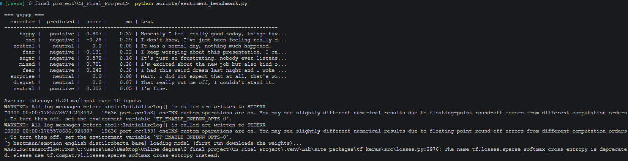
Figure 12. sentiment_benchmark.py output for VADER, showing the 3-class limitation: the surprise and disgust transcripts both fall back to neutral.
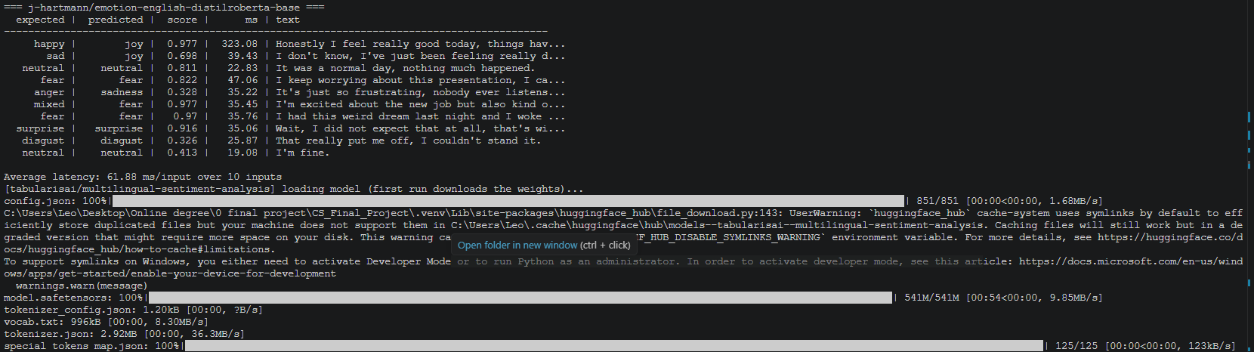
Figure 13. sentiment_benchmark.py output for j-hartmann/emotion-english-distilroberta-base, the selected model - the only candidate to label surprise and disgust correctly.
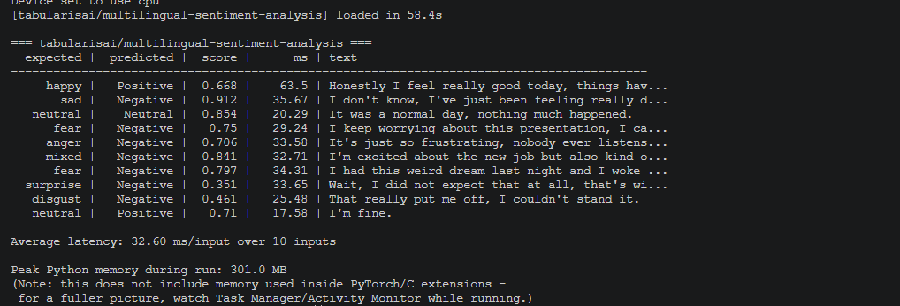
Figure 14. sentiment_benchmark.py output for tabularisai/multilingual-sentiment-analysis, showing the negative-label bias described above, with the run's peak memory figure.

Stage 4 results: Local language model (Ollama)
Integration was confirmed by running complete sessions end to end and inspecting the resulting logs. The language stage received the combined Stage 1-3 output and returned a reflection that referred to the specific scenes and spoken content of that session, with the seek_help flag set where the reply recommended professional support (Figure 15).
Figure 15. The profile section of a session log, with seek_help correctly set to true for a session whose generated reflection recommended professional support.
One notable limitation surfaced during this testing: on at least one follow-up turn, llama3.2 produced a reply that misjudged the intent of an ambiguous user message and responded with an inappropriate, unrelated safety refusal rather than asking for clarification or responding sensibly. The reply was incorrect and out of context rather than unsafe in itself, but it illustrates a real risk for this project: a small local model can misread short or ambiguous input in unpredictable ways, and for a tool operating in a mental-health-adjacent context, an erratic or nonsensical response at the wrong moment could undermine user trust or feel dismissive. This single incident is followed up systematically below.
A structured robustness test (chat_robustness_test.py) was then run to replace this single anecdote with a systematic count: 10 varied and ambiguous follow-up messages - spanning short/terse input, an off-topic question, ambiguous emotional statements, a direct diagnosis request, sarcasm, a meta-question about data handling, nonsense input, a topic shift, mild distress language, and a reference back to earlier context - were sent through the same conversation history on both llama3.2 and qwen2.5:3b, starting from an identical profile context on each model. Table 7 summarises the outcome per model.
Model | On-topic / appropriate | Inappropriate refusal | Factually wrong (system-inconsistent)
llama3.2 | 7/10 | 2/10 | 1/10
qwen2.5:3b | 9/10 | 0/10 | 1/10
Table 7. Chat robustness test, 10 messages per model, classified from the full reply transcripts (see logs/chat_robustness_results.csv).
The chat test gives a higher-level robustness measure than a single successful conversation: llama3.2 produced appropriate/on-topic responses for 7/10 prompts (70%), with 2/10 inappropriate refusals and 1/10 system-inconsistent factual error; qwen2.5:3b produced 9/10 appropriate responses (90%), no inappropriate refusals and 1/10 system-inconsistent factual error. The latter error is especially important because both models incorrectly stated that conversation data were not saved, while the application actually writes session logs locally. This means safety-critical system facts should be stated by fixed application-level text rather than delegated to the language model.
Model | Time to first token | Total generation time | Approx. size | Output quality (notes)
llama3.2 | 10.46s | 28.04s | ~2GB | 1332-character reply; explicitly recommended professional support given the fear signal
qwen2.5:3b | 8.79s | 18.99s | ~2GB | 789-character reply, more concise; covered the same emotional patterns but did not recommend professional support for a comparable distress signal
Table 8. Local LLM comparison for profile generation, run on an identical sample emotion summary (facial emotions + transcript + sentiment scores) on an Intel Core i7-1185G7, 16GB RAM, no dedicated GPU.
qwen2.5:3b is roughly 30-40% faster on both metrics and produces noticeably shorter output. However, the missing seek-help recommendation on a prompt with a comparable distress signal to earlier llama3.2 tests is a meaningful finding given the project's severity-assessment design requirement (see Design chapter): a faster model is of limited value if it is less consistent at surfacing this specific, safety-relevant behaviour. llama3.2 was therefore retained as the primary model for the current build. This is based on a single comparison prompt rather than a systematic test and should be treated as an initial finding, not a conclusive result - see the structured chat-testing item above.

End-to-end pipeline timing
Run | Vision (stimulus) | Spoken Q + transcription | Text-emotion | Profile generation | Total (excl. chat)
1 | 41.48s | 26.41s | 2.41s | 46.97s | 117.27s
2 | 49.45s | 20.92s | 13.81s | 34.57s | 118.74s
3 | 47.48s | 57.70s | 10.34s | 32.23s | 147.75s
Average | 46.1s | 35.0s | 8.9s | 37.9s | ~128s
Table 9. End-to-end pipeline timing across three full live runs (consent through profile generation, excluding the open-ended follow-up chat), on an Intel Core i7-1185G7, 16GB RAM, no dedicated GPU.
Table 9 reports three complete live runs, timed per stage. Chat is excluded from the reported total because it is user-paced and open-ended rather than a fixed system cost; including it (run 1: 138.13s, run 2: 144.52s, run 3: 194.50s) would conflate the pipeline's own processing time with however long the user chooses to keep talking. The consistent finding across all three runs is that the system takes just under two minutes, on average around 128 seconds, from the start of the stimulus to a delivered profile, with no cloud round-trip anywhere in that time. Profile generation (Ollama, average 37.9s) and the vision stage (average 46.1s, which includes the 36-second stimulus display time (twelve images at three seconds each) rather than being pure DeepFace inference cost) are the two largest and most variable contributors; text-emotion analysis is consistently negligible (2.4-13.8s, the higher end likely reflecting model warm-up on first call rather than a real per-session cost). Figure 16 shows a timing log as written at the end of a run. This is the honest trade-off that comes with keeping everything local (see Design chapter): privacy and zero data transmission are paid for with a real wait of roughly two minutes before the user sees their reflection. A cloud-based version could probably make that faster, but only by sending emotional data off the device.
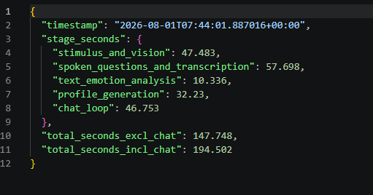
Figure 16. A timing log written at the end of a completed session, recording per-stage seconds and both totals. This is the raw form of the run 3 column in Table 9.

Session logging
Every completed run writes a timestamped JSON log recording whether consent was given, whether the run was a demo, the three question-and-answer pairs, the output of each stage, the generated reflection and the full chat transcript (Figures 8, 9 and 17). This means each session can be checked afterwards, demo runs stay clearly separate from participant runs, and the evidence used throughout this chapter came straight from the logs rather than being copied by hand from the terminal.
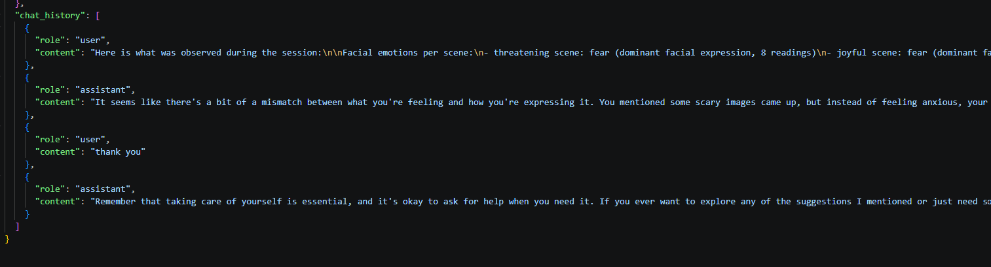
Figure 17. The chat_history field of a session log. The assistant's first reply refers directly back to the mismatch identified in the profile it had just generated, confirming session context is retained across turns.

Unit testing
Module | Tests | Main coverage
Vision | 17 | Dynamic stimulus scheduling, scene/stimulus lookup, positioning
Sentiment | 6 | Empty input, result extraction, model initialisation
Profile generator | 8 | Prompt assembly, safety flag, chat history
Session flow | 15 | Consent, questions, demo mode, closing resources
Table 10. Unit-test coverage by module. Tests mock hardware and external model services so the suite isolates project-owned deterministic logic.
A pytest suite covers deterministic, hardware-independent logic across the four testable modules, using mocks so tests run offline without real models or hardware (Table 10). Vision tests cover dynamic OASIS scheduling and scene/stimulus lookup; sentiment tests cover empty-input handling and model-result extraction; profile-generator tests cover prompt construction, safety flagging and conversation state; session tests cover the fail-closed consent gate, question ordering, demo mode and closing resources. The full suite of 46 tests passes in 16.16s with no external services, hardware or downloaded models required (Figure 18), providing regression evidence for the project-owned logic rather than validating the underlying pre-trained models.
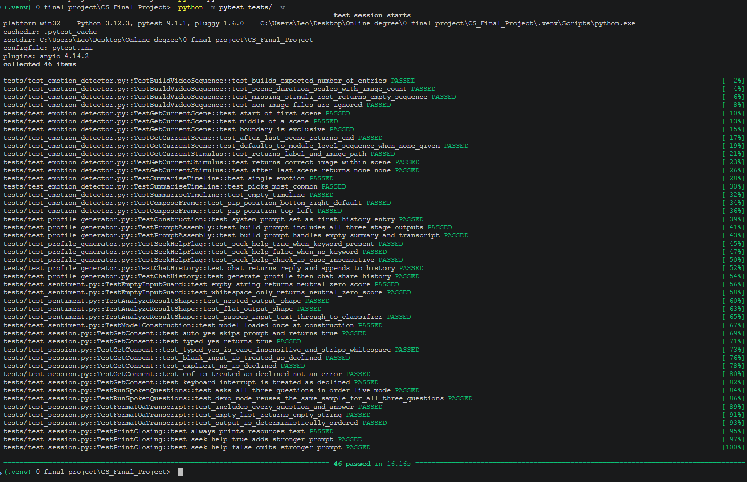
Figure 18. The full pytest suite: 46 tests across the four testable modules, passing in 16.16s with no external services, hardware or downloaded models required.

Response to preliminary feedback
Peer-review feedback from Topic 7 was obtained during development but is not reported here, since the responses were collected before the guided session, the OASIS stimulus and the chat stage existed and therefore do not describe the system evaluated in this chapter. Refreshed peer-review questions covering those stages are scheduled for the Topic 9 review.
The preliminary feedback identified four connected weaknesses: insufficient critical depth in the literature, over-interpretation of facial-emotion outputs, inadequate safeguards for a sensitive domain, and evaluation that did not sufficiently test integrated robustness. These concerns directly informed the revised scope and evaluation: the project is now framed as a proof of concept; facial outputs are treated as uncertain signals rather than psychological measurements; consent, non-diagnostic framing and professional-help signposting are explicit safeguards; and system-level robustness is assessed alongside component benchmarks.

User testing
A pilot study was run with 5 participants (friends and family, convenience sample) ahead of the full 6-10 person study planned for September. Each participant received a verbal explanation of the session and its non-diagnostic purpose, completed the session, and rated perceived accuracy, clarity and willingness to use the system again on a 1-5 scale. The sample is too small for population-level inference; its purpose was to test the interaction and evaluation instrument before the larger study. Table 11 reports the resulting scores.
Participant | Accuracy | Clarity | Would use again
Participant 1 | 3 | 2 | 4
Participant 2 | 4 | 5 | 5
Participant 3 | 3 | 4 | 4
Participant 4 | 2 | 3 | 3
Participant 5 | 5 | 5 | 5
Mean | 3.4 | 3.8 | 4.2
Table 11. Post-session Likert scores (1-5), n=5 pilot participants; SD values are reported in the Evaluation text.
Willingness to use the system again scored highest (mean 4.2/5), followed by clarity (3.8/5) and perceived accuracy (3.4/5). The sample standard deviations were 0.84, 1.30 and 1.14 respectively, showing substantial individual variation despite the small sample. Two participants reported close agreement with the reflection, while one described it as too general and another said fear was not captured well. These comments align with the model-level findings rather than establishing psychological validity.
A more important finding emerged from the session logs: all 5 sessions were flagged seek_help: true, despite most participants describing themselves as fine, bored, or mildly skeptical rather than distressed. This exposes a potentially serious false-positive pathway. The flag is generated from the profile pipeline rather than clinical assessment, so it cannot be interpreted as evidence of actual risk; it instead demonstrates why a safety flag must be conservative, transparent and evaluated against user-reported context before being treated as meaningful.
Participant comments also suggested two lower-priority interface changes: adding audio to the stimulus presentation and making the visual interaction more accessible. These were recorded as future iterations rather than implemented during the frozen draft build.

Inclusive design and demographic limitations
Most stage-level benchmarks were produced by one user, on one machine, in English. They therefore cannot establish accuracy across demographics, accents or hardware. The system also inherits demographic limitations from its pre-trained models: facial-analysis performance can vary by skin tone and gender, while speech recognition can vary by accent and language. These are treated as validity and inclusion constraints rather than claims of measured demographic performance.

6. Conclusion
This project set out to demonstrate a fully local, privacy-preserving proof of concept for emotional self-reflection by orchestrating facial-emotion recognition, speech transcription, text-emotion analysis and a local language model. The implemented system achieves that technical objective: the four stages run through a guided, consent-first session, generate a non-diagnostic reflection, support follow-up conversation and save the session locally without cloud processing.
The implementation demonstrates that the models can be combined into a coherent pipeline rather than used as isolated demonstrations. Model selection was evidence-led: faster-whisper outperformed the original Whisper implementation on the test audio; j-hartmann achieved the strongest result among the tested text-emotion candidates while sharing DeepFace's seven-label vocabulary; DeepFace was retained over FER after controlled comparison; and llama3.2 was retained over qwen2.5:3b because the latter, although faster and better behaved on the structured chat test, failed to surface professional-help guidance for a comparable distress signal - a trade-off that a larger safety-focused comparison should revisit. The system is also supported by 46 passing unit tests and three end-to-end timing runs.
The evaluation does not establish psychological validity. Facial-emotion results varied across runs and were sometimes direction-inconsistent, while the local language model occasionally over-interpreted low-information input. The structured chat test found inappropriate refusals from llama3.2 and, more seriously, both tested language models incorrectly claimed that conversations were not saved even though the system writes the full session locally. This is a direct limitation of relying on a general-purpose language model to explain system behaviour and is a priority safety issue. The pilot study further found an average accuracy score of 3.4/5 compared with 3.8/5 for clarity and 4.2/5 for willingness to use again; importantly, all five pilot sessions triggered the seek-help flag, suggesting that this mechanism is currently too sensitive to ambiguous or mixed-emotion input.
The main contribution of the project is the integration and evaluation of the local AI components. The results do not support claiming that the system can accurately infer psychological state. The average processing time of roughly 128 seconds shows what keeping everything local costs the user. At the same time, the inconsistent facial-emotion readings, the small benchmark sets, the failures in the chat test and the seek-help flag firing in every session all show that getting the components to work together does not make the output psychologically or clinically sound. The right description at this stage is a proof of concept. Before any wider or clinical use could be considered, the project would need a larger and deliberately diverse evaluation, tested safety cases, controlled testing of the assumptions behind facial-emotion classification, user control over how long data is kept and when it is deleted, and success criteria agreed in advance for the system as a whole.

References
Abby Health. (2026). Abby AI: Medical decision support system. https://www.abbyhealth.com
Affectiva. (2016). The science behind Affectiva's emotion AI. https://www.affectiva.com
Barrett, L. F., Adolphs, R., Marsella, S., Martinez, A. M., & Pollak, S. D. (2019). Emotional expressions reconsidered: Challenges to inferring emotion from human facial movements. Psychological Science in the Public Interest, 20(1), 1–68. https://doi.org/10.1177/1529100619832930
Buolamwini, J., & Gebru, T. (2018). Gender shades: Intersectional accuracy disparities in commercial gender classification. Proceedings of Machine Learning Research (Conference on Fairness, Accountability and Transparency), 81, 1-15.
Ezell, A. (2026). Evaluating AI chatbots for mental health diagnosis and treatment planning [Unpublished study]. Widener University.

Ghatoray, S. K., & Li, Y. (2025). Automated UX insights from user research videos by integrating facial emotion and text sentiment (arXiv:2503.22510). Department of Computer Science, Brunel University London. https://arxiv.org/abs/2503.22510
Graham, C., & Roll, N. (2024). Evaluating OpenAI's Whisper ASR: Performance analysis across diverse accents and speaker traits. JASA Express Letters, 4(2), Article 025206. https://doi.org/10.1121/10.0024876
Hartmann, J. (2022). Emotion English DistilRoBERTa-base [Model]. Hugging Face. https://huggingface.co/j-hartmann/emotion-english-distilroberta-base
Hugging Face. (2024). Text classification. https://huggingface.co/tasks/text-classification
Hutto, C. J., & Gilbert, E. (2014). VADER: A parsimonious rule-based model for sentiment analysis of social media text. Proceedings of the Eighth International AAAI Conference on Weblogs and Social Media, 216-225.
Kurdi, B., Lozano, S., & Banaji, M. R. (2017). Introducing the Open Affective Standardized Image Set (OASIS). Behavior Research Methods, 49(2), 457-470. https://doi.org/10.3758/s13428-016-0715-3
Laidi, C., Blampain-Segar, L., Godin, O., de Danne, A., Leboyer, M., & Durand-Zaleski, I. (2023). The cost of mental health: Where do we stand in France? European Neuropsychopharmacology, 69, 87–95. https://doi.org/10.1016/j.euroneuro.2023.02.004
Lee, J., Lee, D., & Lee, J.-g. (2022). Influence of rapport and social presence with an AI psychotherapy chatbot on users’ self-disclosure. International Journal of Human–Computer Interaction. https://doi.org/10.1080/10447318.2022.2146227
Miller, R. (2017, September 13). New Affectiva cloud API helps machines understand emotions in human speech. TechCrunch. https://techcrunch.com/2017/09/13/new-affectiva-cloud-api-helps-machines-understand-emotions-in-human-speech/
Ollama. (2024). Ollama documentation. https://ollama.com
OpenCV. (2026). OpenCV: Open source computer vision library. https://opencv.org
Radford, A., Kim, J. W., Xu, T., Brockman, G., McLeavey, C., & Sutskever, I. (2022). Robust speech recognition via large-scale weak supervision (arXiv:2212.04356). OpenAI. https://arxiv.org/abs/2212.04356
Riedl, R., Hogeterp, S. A., & Reuter, M. (2024). Do patients prefer a human doctor, artificial intelligence, or a blend, and is this preference dependent on medical discipline? Empirical evidence and implications for medical practice. Frontiers in Psychology, 15, 1422177. https://doi.org/10.3389/fpsyg.2024.1422177
Serengil, S. I., & Ozpinar, A. (2020). LightFace: A hybrid deep face recognition framework. 2020 Innovations in Intelligent Systems and Applications Conference (ASYU), 23-27. https://doi.org/10.1109/ASYU50717.2020.9259802
SYSTRAN. (n.d.). faster-whisper [Computer software]. GitHub. https://github.com/SYSTRAN/faster-whisper
World Health Organization. (2021). Ethics and governance of artificial intelligence for health: WHO guidance. World Health Organization. https://www.who.int/publications/i/item/9789240029200

